A simulation study on the modulation of information transfer in feedforward networks.

Abstract

There are vast amount of correlated neural activities, such as oscillation and synchronization, observed in the brain. These activities are one of the important keys for communication in the brain. However, the questions on how to modulate the synchronization level and how these synchronized activities affect spike transfer from one layer to another layer in different convergent connection conditions are not clearly understood. In this work, we employ computer simulation of realistic neural network to address the questions.

The neural network consists of two layers of conductance based single cell model, source layer and target layer. The interlayer connections follow statistical wiring diagram, for which, strength and connectivity of the connection depend on the distance between the target cell and the source cells which define as Gaussian-Gaussian (GG) rule. For comparison, we built two other convergent connection rules while keeping connection probability constant. One is the constant strength of connection called Uniform-Uniform (UU) rule and another is the random strength of connection that follows negative exponential distribution, Uniform-Exponential (UE) rule. Then, the responses on target layer were measured from various convergent conditions. To study how the synchronization of input contributes to the neuron network’s response, we compared the oscillating input and the static input given to the system.

We showed that output firing rate increases when oscillating input were given to the network despite the average input firing rate were equal to those in static input. Also, we found that when the strong oscillation were given the same level of output response can be made with less connection strength compare to the static case. Next, we discovered that the network with oscillation input can induced more output response. Similarly, the input and output synchronization get stronger when the oscillation input were given. In addition, the different in oscillation and static input were large in UU convergent connection rule compare to the two other rules.

In summary, we found that neural network with Uniform-Uniform convergent connection rules could selectively allow spike information from specific synchronization level to be transferred to another layer with least cost of connection compared to the other two rules. This work suggests the combined role of input synchronization level and interlayer connection rules as the key to understand brain connection.

**Chapter 3. Results**

In the previous chapter, a simple feedforward network with two layers has been made. The responses of various convergent connections in such network to static and oscillating input are discussed in this section. The goal for this research study is to investigate how information transfer as infer from output firing rate can be modulate by level of synchronization in the input and which convergent connection rule has the highest output response to this input synchronization.

First, we describe the unique activity map under various kind of input and various kind of convergent con- nection rules. We then show the increase in output firing rate when feedforward connection strength increase and when the synchronization level in input increase. We demonstrate that in Uniform-Uniform convergent rule(UU) has highest response gain from static input to oscillating input when compare to other convergent rules. Finally, we reveal that the UU rule has highest number of induced spike gain and it is highly dependent on phase of input oscillation. The explanation on why the UU rule is most sensitive to synchronized input based on idea of temporal summation was also introduced.

**3.1 The activity map of target layer shows unique response for each com- bination of convergent rules and input pattern**

For each combination of input pattern and convergent rules, an activity matrix has been made by assigned each element as average firing rate of target layer at given convergent conditions ( *ri* , *wi* ). Three convergent rules and three input levels multiply to nine cases of activity matrix as shown in figure 3.1 The contour plot from this matrix build up the activity map for each condition(Figure 3.2). In the activity map the lighter color mean the higher firing rate. In all the cases, when convergent conditions increase the response increase. However, the rate of increasing are different in each case as that can be easily observed when the compare the same position of the map in all cases (red dot position; *ri* = 80, *wi* = 80 ).

To explore the role of each convergent condition parameter, the output firing rate were plot when one pa-

rameter is fixed. If range of connection is fixed, the output firing rate vs. weighting factor parameter were plot (Figure 3.3). Likewise, if weight condition is fixed, the output firing rate vs. range parameter were plot (Fig- ure 3.4). When observe the change in the output firing rate, we found that the strong oscillating input has highest response compare to the other input pattern in all cases.

**3.2 The feedforward network with strong oscillation input has highest output firing rate**

According to the observation in the previous part, it showed that the oscillating input gave higher response compare to the static input. Next, the general analysis is made for all the convergent conditions by look at relation- ship between output firing rate and total feedforward strength ( or total weight summation as introduced earlier). From this plot (Figure 3.5 ), it can clearly be seen that as total feedforward connection strengthen the output firing rate also increase. In addition, the firing rate in all convergent rules increases for oscillating input compare to the static input case. The slope of this plot can be considered as gain or average firing rate per unit feedforward

Static Input



Weak Oscillation

Strong Oscillation



w

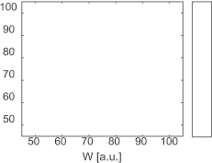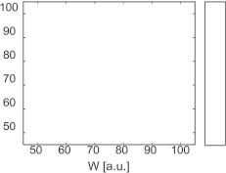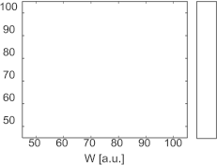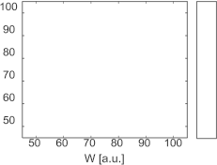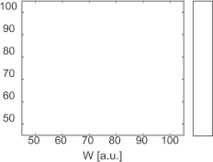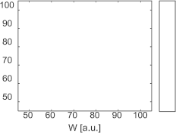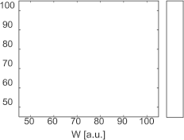

**GG**

A’   

*Strength*

3𝜎 r

***Distance***

𝑤 **UU**

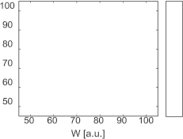

*Strength*

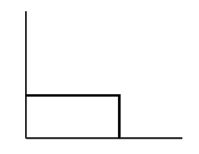A’   

R=3𝜎 r

***Distance***

**UE**

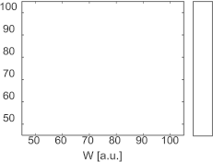

𝑝

*Probability*

𝑝 𝑤 = 𝑒 (−𝑤)

***Strength*** 𝑤

Figure 3.1: The activity matrix shows response of a feedforward network under different condition. Row : Con- vergent Rules; Gaussian-Gaussian(GG), Uniform-Uniform(UU), and Uniform-Exponential(UE) , Column : Input

pattern; static, weak oscillation, and strong oscillation input.

Static Input



Weak Oscillation

Strong Oscillation

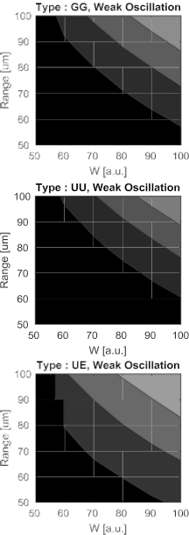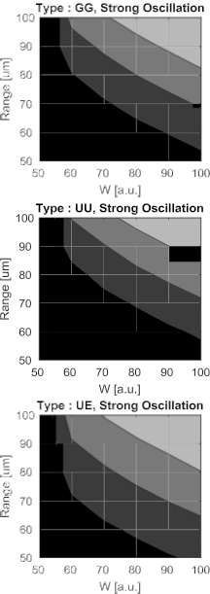w

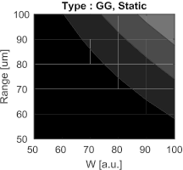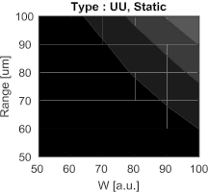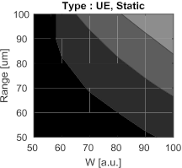

**GG**

* * *

*Strength*

3𝜎 r

***Distance***

𝑤 **UU**



*Strength*

* * *

A’

R=3𝜎 r

***Distance***

**UE**



𝑝

* * *

*Probability*

𝑝 𝑤 = 𝑒 (−𝑤)

***Strength*** 𝑤

Figure 3.2: The Activity Map that made from contour plot of activity matrix. Red dots shows the location of same convergent condition in each case but they have different response due to input pattern and convergent rules

W [a.u.]

Range [um]

(Hz)

SO SO

WO

(Hz)

(Hz)

WO SO S

S WO

S

Figure 3.3: The observed response of network when range of connection fixed and varies weight

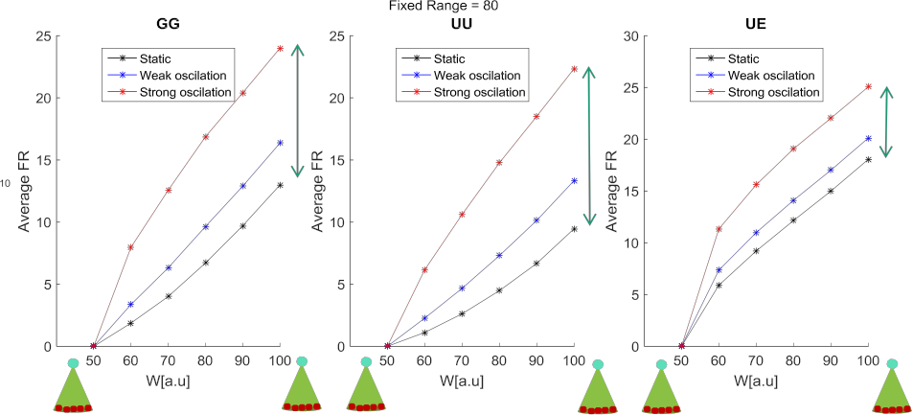

SO



Range [um]

FR(Hz)

(Hz)

(Hz)

(Hz)

WO

W [a.u.] S

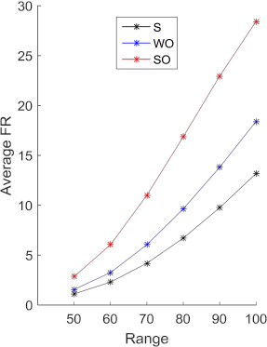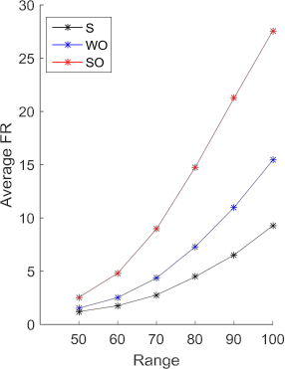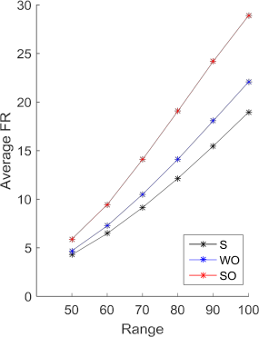

Range [um] Range [um] Range [um]

Figure 3.4: The observed response of network when strength of connection (or weight) fixed and varies range of connection

strength. Higher gain value means the feedforward network can transfer more spikes to output layer with the same connection strength to the lower gain value. The slope or gain from this response function were plot in Figure 3.6. From this plot, it can clearly be seen in all convergent rules that the strong oscillation input has highest gain, then weak oscillation and static input respectively. If we examine it further by look at the different in slope of strong oscillation input and that of static input of all convergent rules, we found that the Uniform-Uniform model has highest different in the gain value as in Figure 3.6 B.

**3.3 The Uniform-Uniform model has highest response gain from static input to oscillating input**

In the previous section, the Uniform-Uniform model has highest oscillation-static different in gain (average output firing rate over total feedforward connection strength ). Plus, it is known from the previous result that the feedforward network with oscillating input has higher response in target layer than the static input case. Next, in order to explore how much response in oscillating input increase from static input, the firing rate of each condition was scattered onto static input axis and oscillating input axis (Figure 3.7). A linear fitting has been

UU GG UE

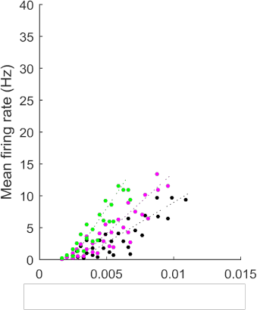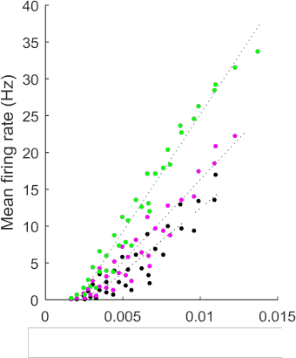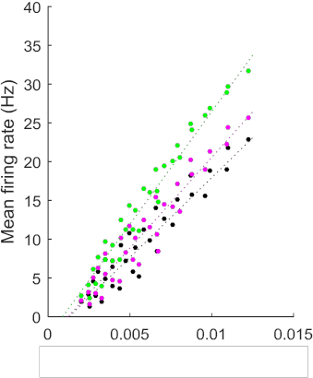

**−** Strong oscillation

**−** Weak oscillation

**−** Static input

Total Feedforward Strength [a.u.] Total Feedforward Strength [a.u.] Total Feedforward Strength [a.u.]

Figure 3.5: The response function (mean firing rate vs. total feedforward strength) of UU, GG, and UE from left

to right. The firing rate increases when connection strengthens.

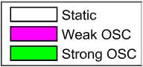

A B

4

2

2

Gain [a.u.]

SO-S ∆Gain [a.u.]

(All significantly different; t-test, p< 0.05)

(All significantly different; t-test, p< 0.05)

Figure 3.6: Comparison of slope or gain. A. Firing rate increases for oscillating input. B. The UU model has highest different in firing rate between strong oscillation and static input.

made for data from each of the convergent rules; Gaussian-Gaussian(GG),Uniform-Uniform(UU), and Uniform- Exponential(UE). Then, the slope for each convergent rules population are determine and compared. The slope of this fitted line are defined as gain (output firing rate when given oscillating input over those when static input were given) and are plotted in Figure 3.8. Since there are two kind of oscillation input, two comparisons can be made; weak oscillation vs static(WO-S), and strong oscillation vs static(SO-S). We found that in both comparison WO-S and SO-S, the Uniform-Uniform has highest gain from static to oscillation compare to the other convergent rules. The gain can infer to the sensitivity of each feedforward network to the synchronization level of input.

**3.4 The Uniform-Uniform model has highest number of induced spike gain on target layer from one spike in source layer**

From previous result, the UU model has highest response gain from static input to oscillating input. The further analysis was introduced to quantify the number of output spike that one input spike can made. This analysis starting with counting number of postsynaptic spikes in target layer that following each of the presynaptic spike in source layer when there exist connection between the layer. Then, normalised this count with total number of

**−** UU

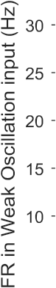

**−** GG

**−** UE

**−** UU

**−** GG

**−** UE



Figure 3.7: Comparing output firing rate of static input and oscillating input. WO-S, and SO-S are comparison

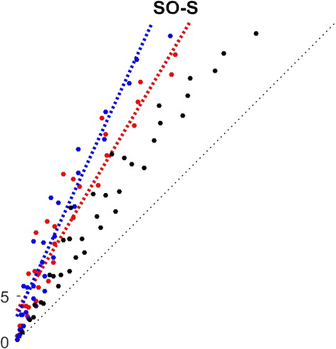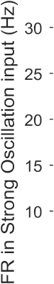

between static input to weak oscillation and strong oscillation respectively.

Gain [a.u.]

Gain = 𝑖𝑛 𝑎𝑐

(All significantly different; t-test, p< 0.05)

Figure 3.8: The Uniform-Uniform model had the biggest gain from static to oscillation.

spikes to get the induced spikes plot. The area under the first peak of the curve cut by baseline activity is the yield induced spike. Scattered these induced spike of static and oscillating input then we can investigated relationship between levels of synchronization in the input.The gain function then calculated from the ratio between induced spike from oscillation and induced spike from static (Figure 3.9. ). The average gain of each convergent rules are shown in Figure 3.10 with two types of oscillation-static comparison. The result shows that the number of induced spikes in the Uniform -Uniform model is highest compare to the other two cases ( GG came in second, and UE had least gain). Plus, overall gains of induced spikes in SO-S case is higher than WO-S case which is expectable since the synchronization level in WO less than SO input. The highest gain in induced spike shows that the Uniform-Uniform convergent rules can produce more spike per one input spike. This result shows analysis in the cell level compare to the previous analysis that were looked upon properties in network level.



Figure 3.9: Example plot for timing of the Induced target spike from a spike in source layer. The shade area, area

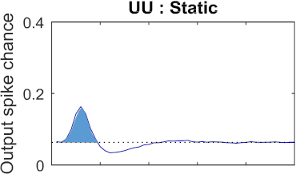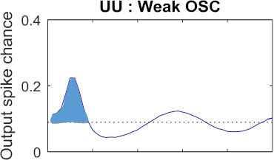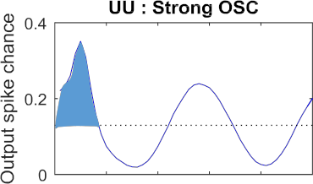

under the first peak to the baseline level, imply the number of total induced spikes.

SO-S WO-S

Number of Induce Spike Gain

Figure 3.10: The number of induced spike gain from static to oscillation input. UU has highest gain in both level of oscillation. (T-test, *p <* 0*.*05)

**3.5 The output spikes in target layer of the Uniform-Uniform model de- pend on phase-lock to oscillation the most**

All previous results showed that the strong oscillation has highest response compare to weak oscillation and static input. Also, the Uniform-Uniform convergent rules has the highest sensitivity to the change in static input to the oscillating input. Next question is how the output spikes related to the phase of the input pattern and how convergent rules behave differently on this phase-tuning. The output response - input phase relation has been made by count output spike timing in one period of input oscillation and sum up all the periods available in simulation. The result can be shown in Figure 3.11. It appeared that the responses are phase lock to crest of oscillating input. Since, we are interested in the gain or different of those value in oscillating input over static input, the plot for each convergent rules are normalised by its spike number in static input. From this curve, the full width half maximum (FWHM) were measure and the average values are plotted in bar graph (Figure 3.12). The small width mean the response are sharply tune to the phase of oscillated input pattern. For Strong oscillation - static input comparison, the UE had stand out biggest width, the UU and GG has small width. Comparing between the UU and GG model, they are significantly different with smaller width in UU. The WO-S comparison showed similar result but overall higher width in all cases. Therefore, this evidence suggest that the Uniform-Uniform model were tuned to phase of input oscillation the most.

FWHM

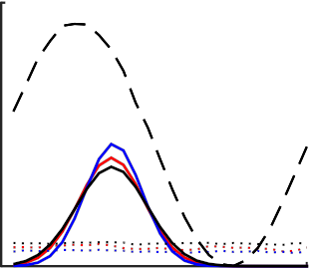

Number of Spike

per time bin

Normalized Number of Spike

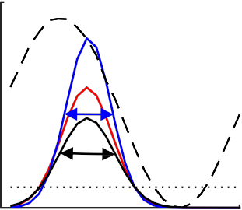Progress time in

one period(ms)

Progress time in

one period(ms)

Figure 3.11: Spiking timing in one period of oscillation input pattern. Left, the example of the tuning plot . Right, the normalised spiking timing by that of static input and the width measurement, Full width at half maximum

(FWHM).

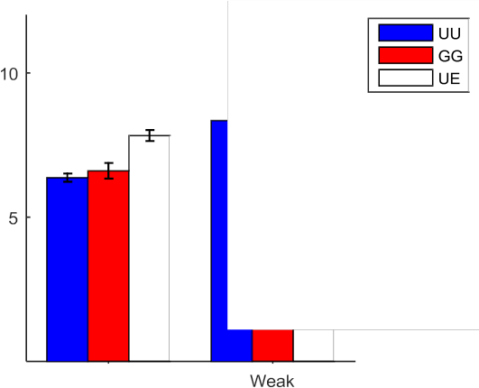

p=0.108

Average Normalized Width

p=0.0248

Figure 3.12: The UU convergent rule has the smallest width indicating the highest tuning to oscillation input compare to the GG and UE rules

**3.6 The Uniform-Uniform model has highest sensitivity to synchronized input because of its optimal distribution of weighting factor**

The Uniform - Uniform convergent rules has the highest sensitivity to the level of synchronization in the input pattern as can be seen from the response gain from static to oscillating input, number of induced spike gain, and phase-lock to the oscillation. The next question is to explain what happen in the Uniform-Uniform convergent rules that make it sensitive to change in synchronization level in input.

We has confirmed that the distribution of connection probability and connection strength are as we design in the methodology chapter(Figure 3.13). Adding on to that, the distribution of weighting factor of all cells in the target layer showed different distribution to that of single target cell due to stochastic in the system, as shown in Figure 3.14). According to this distribution, the UE model has exponential distribution as expected. The UU model has normal-like distribution due to stochastic environment. The Gaussian-Gaussian model has almost flat distribution. The Gaussian distribution has high weighting factor in center population and has lower weight

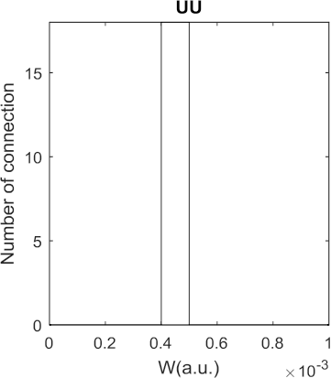

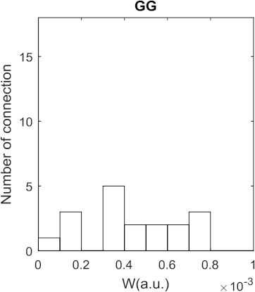Figure 3.13: The distribution of weighting factors of convergent connections to a target cell

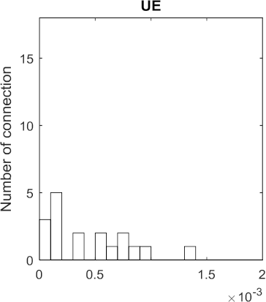

value in boundary. However, due to the increase in area covering by the filter at the boundary where connection probability and weighting factor are low, the compensation for low connectivity effect occurred and bring up the total number of low weight. As a result, the GG model has flat distribution (Figure 3.14). When comparing cumulative sum of these distribution, the UU model clearly had narrow range of strength compare to conventional model like GG model.

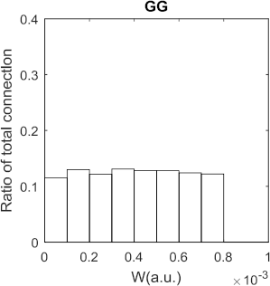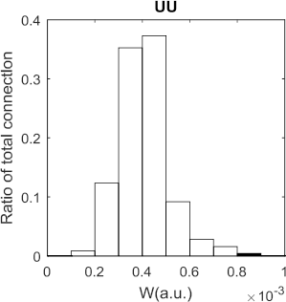3𝜎

2D Gaussian

-3𝜎

-3𝜎

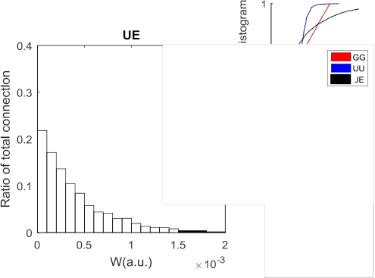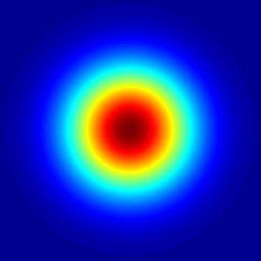

3𝜎

Figure 3.14: The distribution of weighting factors of all convergent connections to target layer. Small figure: Top the cumulative distribution function of weight distribution in all types. Bottom: The plot of 2D Gaussian filter shows increasing in ring area at boundary where the Gaussian value is low compare to the inner area that has high Gaussian value but it got limited space.

The distribution in weighting factor or strength of a feedforward connection is key explanation on its sensitiv- ity to synchronization level in the input. We divided the group of weighting factor into three groups according to their range; low, middle, and high, then use it to explain feedforward connection characteristics and its response. In the case of high connection strength, spike from source cell can make spike in target layer. In case of low connection strength, it is hard to make spike cell from only single spike from source layer. However, at the middle range of connection strength, it is the range that the probability of making spike is not certain but depend on the pattern of input spikes and it can explained by idea of temporal summation in cell conductance (Figure 3.15). When there is no oscillation in the input, the spikes arrive the postsynaptic cell individually (not overlap or not too close to each other). At this middle range of connection strength, the conductance of these single spikes cannot reach threshold of action potential, therefore it cannot produce spike in target cell. If oscillating input were given

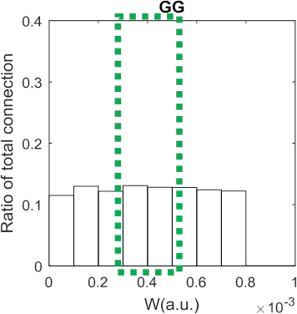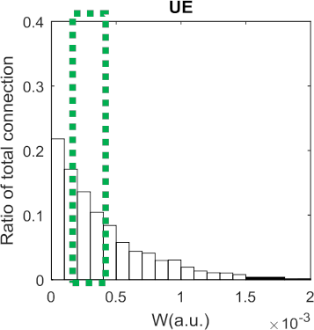W’

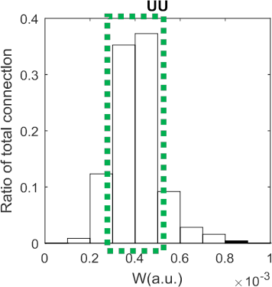Many single spikes

-> middle range w can not drive

target cell

High overlapping spike

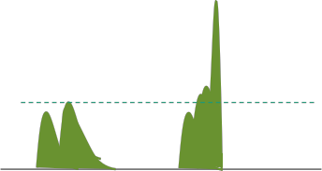-> middle range w can drive target cell

gW’ gW’

Single Spikes

Overlap/ Multiple Spikes

Figure 3.15: The schematic figure to employ idea of temporal summation [7] to explain why the UU model has highest sensitivity to level of synchronization in input

at this same middle range of connection strength, however, there are many spikes with short inter-spike-interval and many overlap spikes (because they are synchronized) which then their conductance sum up as in temporal summation idea and drive spike in target cell. The connection strength in the UU model clustered around middle range that is why the change in static and the strong oscilation in UU model is highest.